Exercises about OS installations

To solve the exercises, create a document with screenshots including the settings for each part.

- Create an empty virtual machine and configure the following settings:

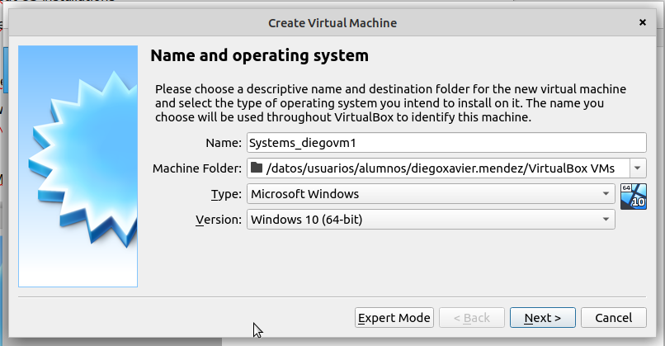

• For Windows 10 (64 bits, or 32 if you do not have enough RAM in your physical
computer)

MACHINE MENU – NEW OPTION. YOU HAVE TO INSERT NAME FOLDER WHERE YOU WANT TO SAVE THE VM, THE OS TYPE AND VERSION.

• 2GB of RAM memory.
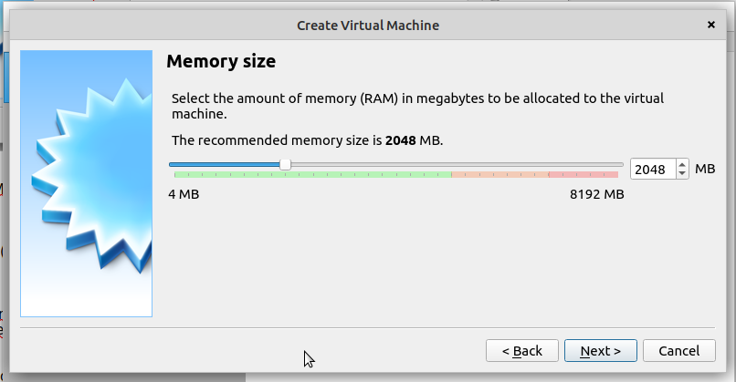
A TOTAL OF 2048 MB HAVE BEEN ALLOCATED TO RAM MEMORY.

• Boot order (CD and hard drive).

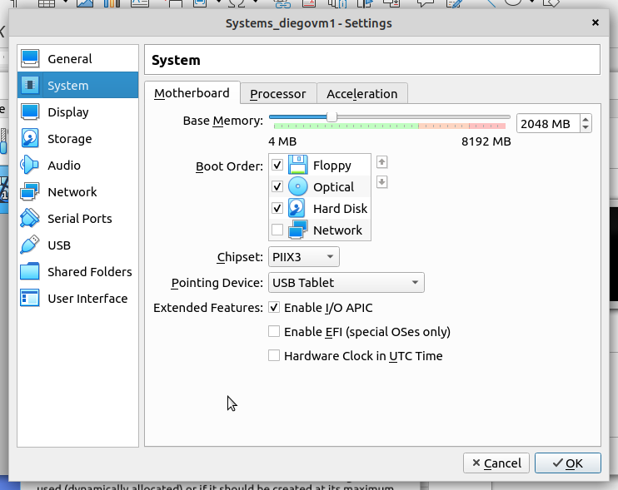

AS YOU CAN SEE INSIDE THE RED CIRCLE, THE BOOT ORDER IS FLOPPY/OPTICAL (CD) AND THEN HARD DRIVE

• Two hard drives: one with 50 GB for the operating system and another one with 30
GB empty. Select the type of disk that can dynamically increase.

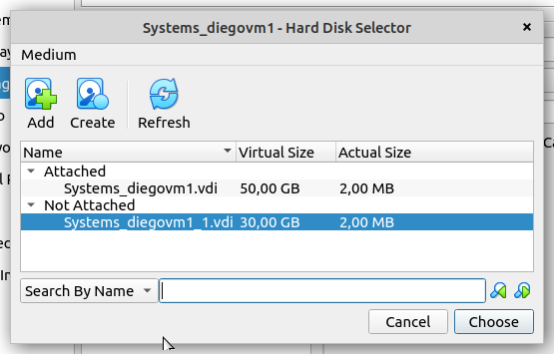

TWO DISKS OF 50 AND 30GB EACH CREATED AND WITH THE DYNAMICALLY ALLOCATED OPTION SHOWN BELOW WE CAN CREATE THE RECQUIRED DISK.
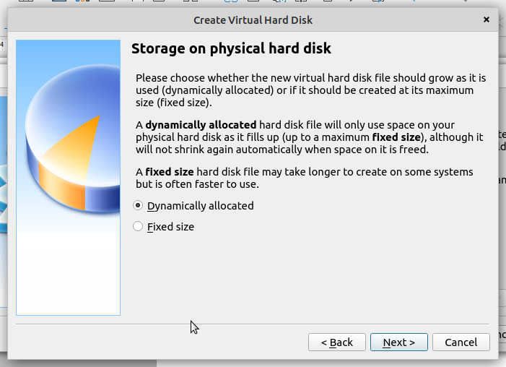

2. Install Windows 10 in the virtual machine from exercise 1. You must add the following
settings:

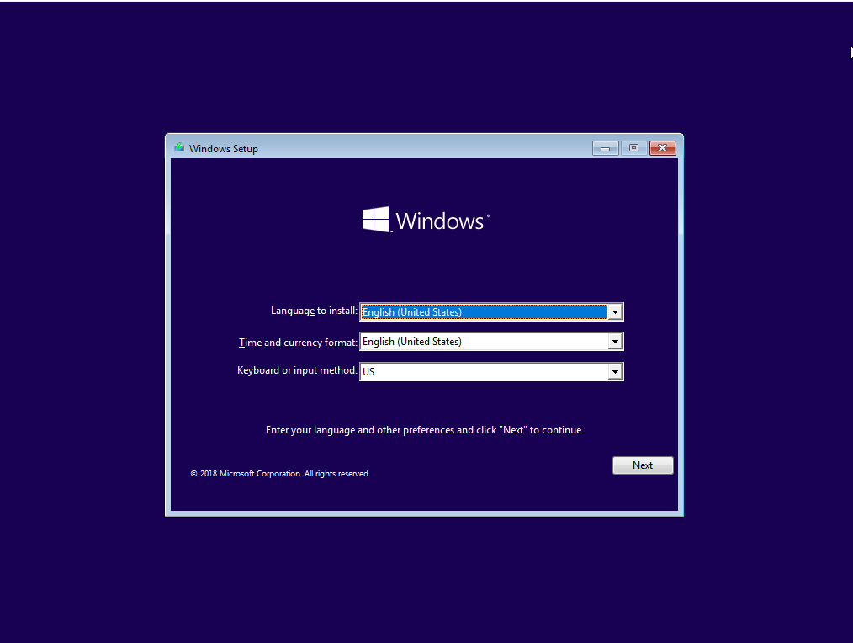

THIS IS THE FIRST WINDOW IN THE INSTALLATION PROCESS. WE WONT SHOW MORE WINDOW OPTIONS AS THEY ARE NOT NECESSARY FOR SETTING A FUNCTIONAL OPERATING SYSTEM. THE ONLY OPTIONS THAT WOULD BE USEFUL ARE THE KEYBOARD OPTIONS TO BE SETUP IN SPANISH BECAUSE OF THE SETUP WE CURRENTLY HAVE.

• USB 3.0 support.
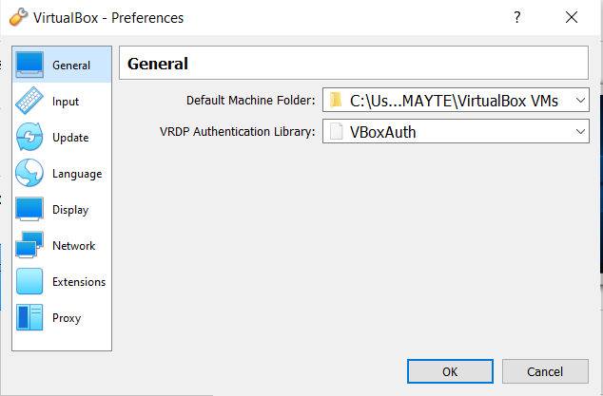
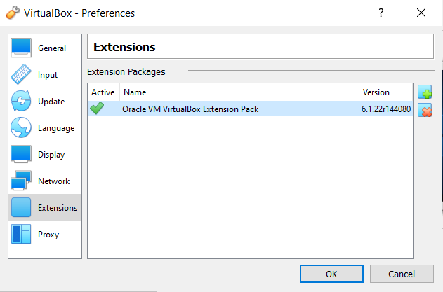

FIRST YOU HAVE TO INSTALL THE VIRTUALBOX EXTENSION PACK.

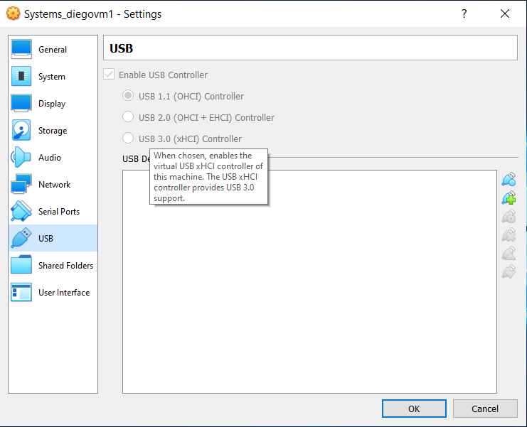

AFTER THIS YOU CAN ENABLE THIS OPTION FOR USB 3.0 SUPPORT OR THROUGH PLUG N PLAY OPTION INSISDE THE VM.

• Shared folders.

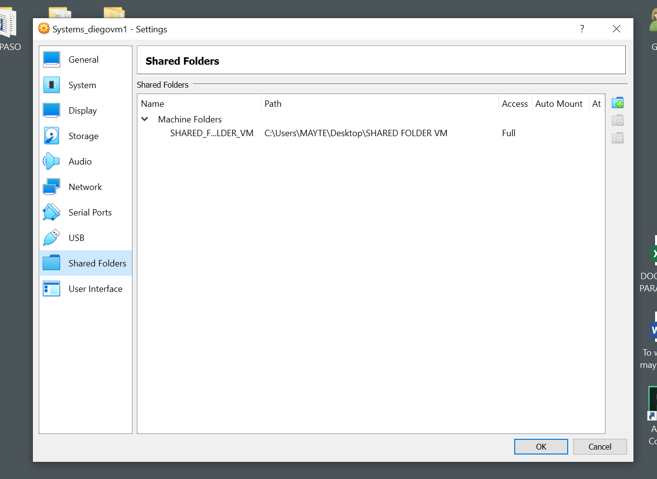

IN THE SETTINGS OPTION OF THE VM IN VIRTUALBOX, SELECT SHARED FOLDER AND CLICK ADD IN ORDER TO CHOOSE WHICH FOLDER YOU WANT TO SHARE BETWEEN USERS.

• Internet connection including access to the rest of computers of the network.

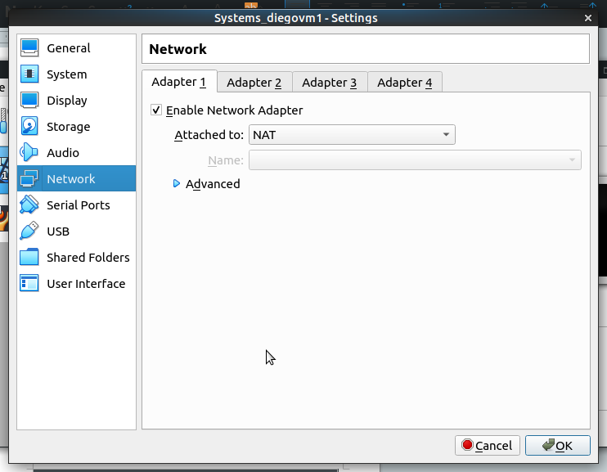

WITH NAT OPTION WE CAN HAVE ACCESS TO INTERNET WITH THE VM.

• You will be able to copy and paste from the host to the guest and vice versa.

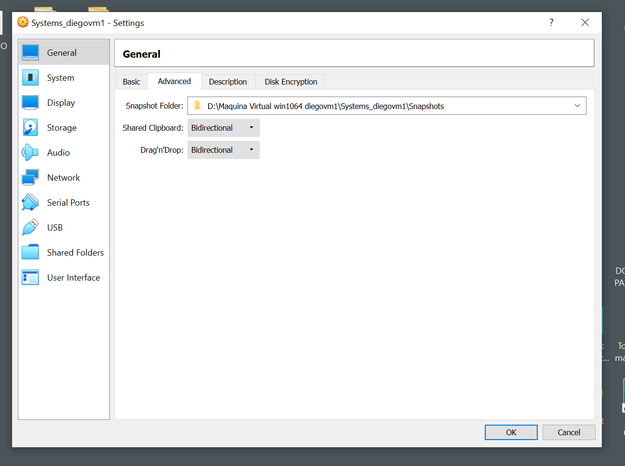

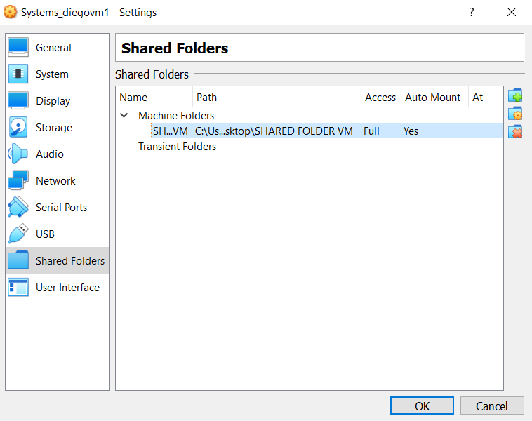

WITH BIDIRECTIONAL OPTION ON WE CAN COPY AND PASTE TO AND FROM THE VM. WE FIND THIS IN SETTINGS IN VIRTUAL BOX, GENERAL MENU. FOR SHARED FOLDER YOU CHOOSE THE PATH AND SELECT THE AUTO MOUNT OPTION.

3. Create another 64-bits virtual machine and install Ubuntu 16.04. The virtual machine must
meet the following requirements:

• 2 GB of RAM memory.

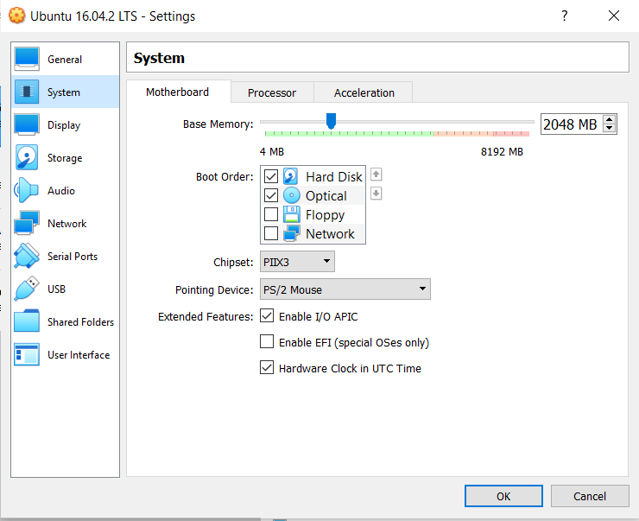

FOR THE UBUNTU VM THE SAME PROCESS IS FOLLOWED AND WE CHOOSE THE 2018 MB RECQUIRED FOR RAM MEMORY.

• Just one disk of 30 GB.

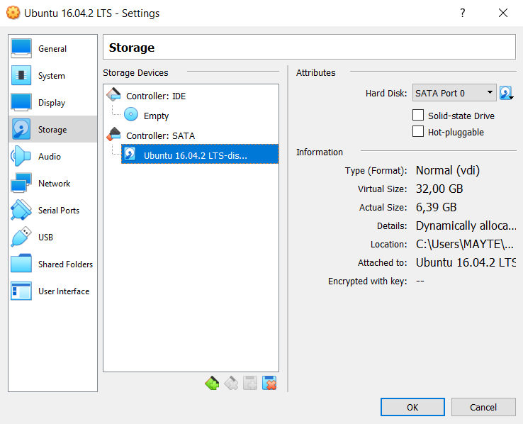

THIS IS ANOTHER VIEWING OPTION FROM THE STORAGE SETTINGS WHERE WE CAN SEE THE 32 GB OF DISK CREATED FOR THE UBUNTU MACHINE.

• A shared folder to an external disk.

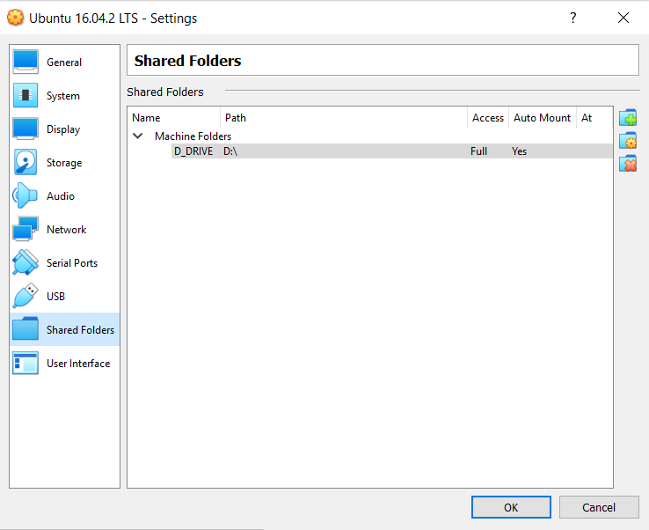

SAME AS WITH THE WINDOWS VM WE CHOOSE THE FOLDER WE WANT TO SHARE, IN THIS CASE THE EXTERNAL D: DRIVE AND WE SELECT THE AUTOMOUNT OPTION.

• Internet connection.

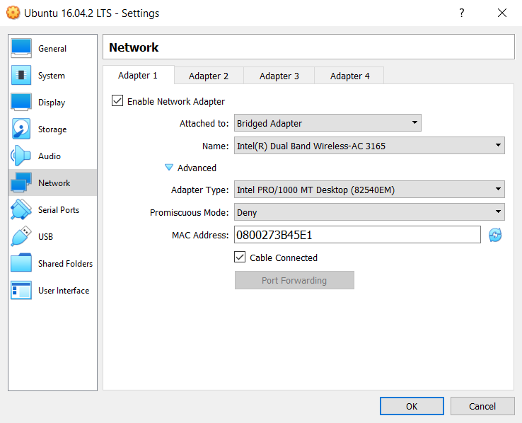

NETWORK SETTINGS AND THEN CHOOSE BRIDGED ADAPTER TO HVE INTERNET CONNECTION. THE NAT OPTION IS ALSO USEFUL HERE.

• You will be able to copy and paste from the host to the guest and vice versa.

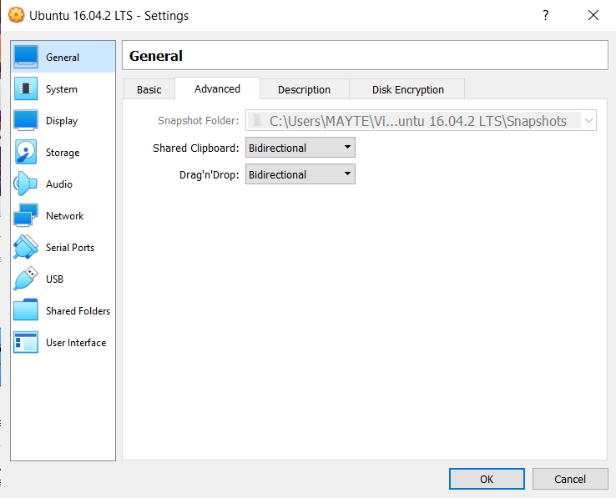

AS WITH THE WINDOWS VM, WE GO TO THE GENERAL –ADVANCED OPTIONS AND ENABLE THE SHRED CLIPBOARD AND DRAG N DROP OPTIONS TO BE ABLE TO COPY AND PASTE FROM THE HOST TO THE VM MAND VICEVERSA.

4. Create the snapshots like in the picture below using one of the virtual machines created in the previous exercises. Before each snapshot, you must change something in the operating system. This tool is normally used when performing a critical action or installing software. But, in this case, you can do something so easy as creating a new file to study the different states.

Then, complete the following actions in order:

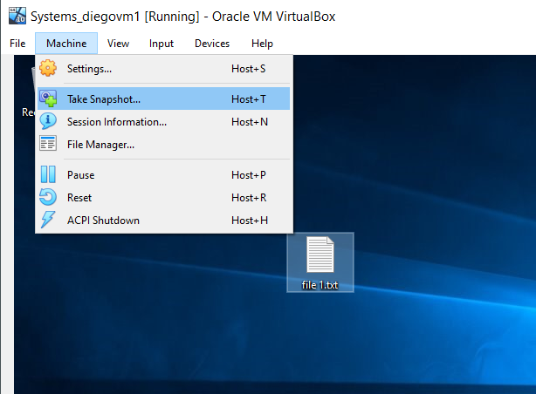

FIRST WE CREATE AN INITIAL STATE SNAPSHOT FROM MACHINE MENU—TAKE SNAPSHOT
• Restore State 2
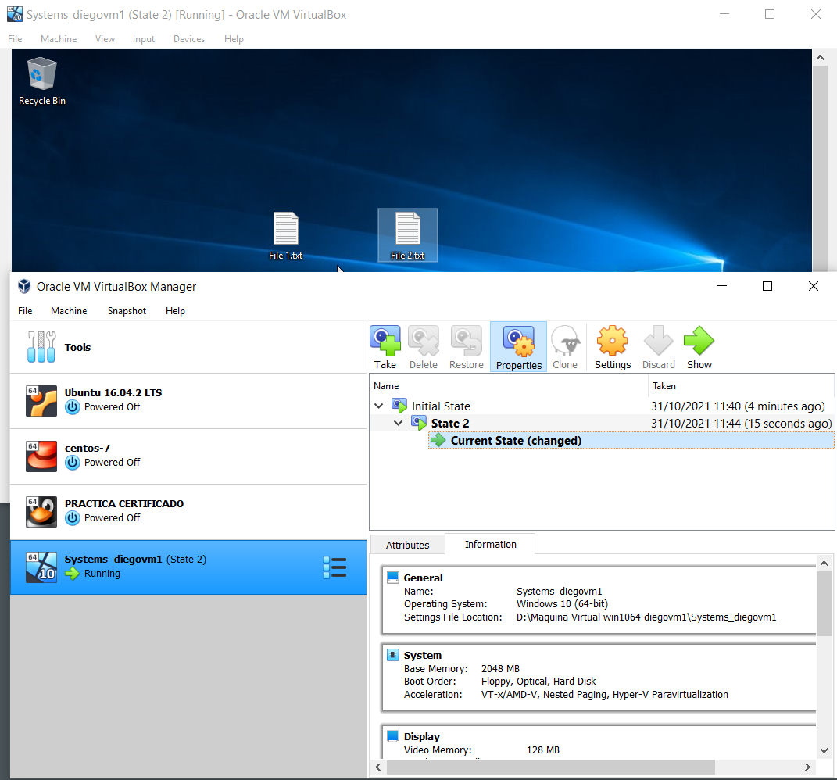

NOW WE CREATE A NEW FILE IN THE VIRTUAL MACHINE AND TAKE A NEW SNAPSHOT NAMED STATE 2. WE REPEAT THE PROCESS TO CREATE STATE 2.1

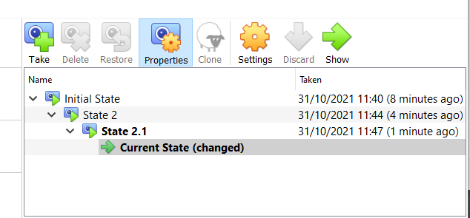

NOW WE HAVE STATE 2 AND STATE 2.1 CREATED. WE WILL SHUT DOWN THE VM AND RESTORE STATE 2 DIRECTLY.

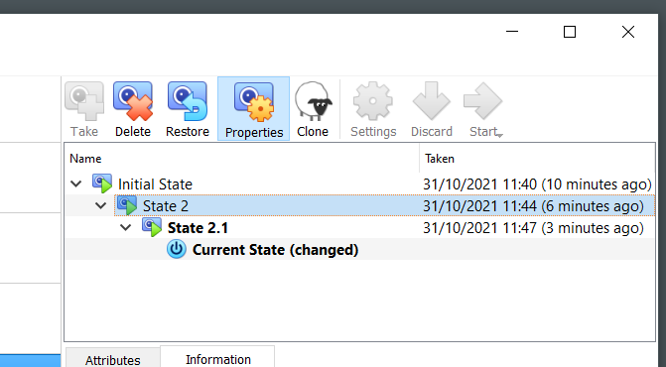

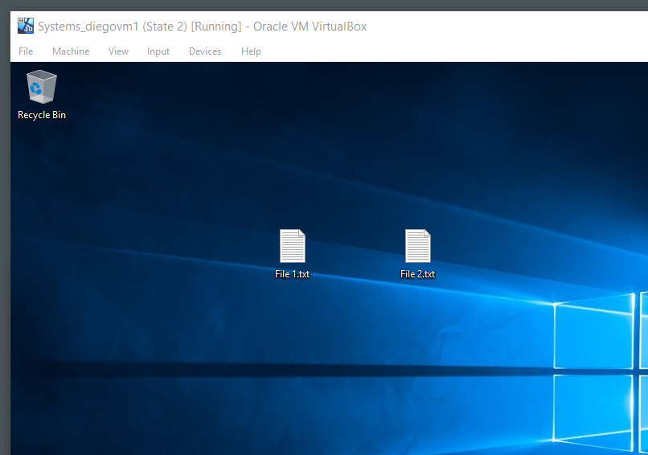

YOU CAN SEE THAT FILE 2.1 IS NO LONGER THERE BECAUSE WE RESTORED ONLY STATE 2 WHICH ONLY CONTAINED FILE 1 AND FILE 2.

• Delete State 2.1 and explain what happens

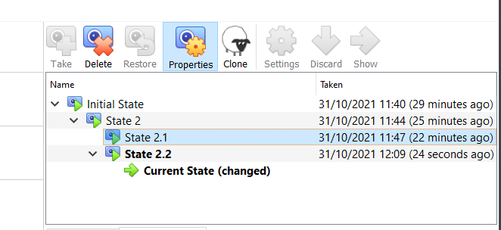

WHEN WE DELETE STATE 2.1 THE FILE CREATED IN THIS STATE DISAPPEARS.

• Restore State 2.2

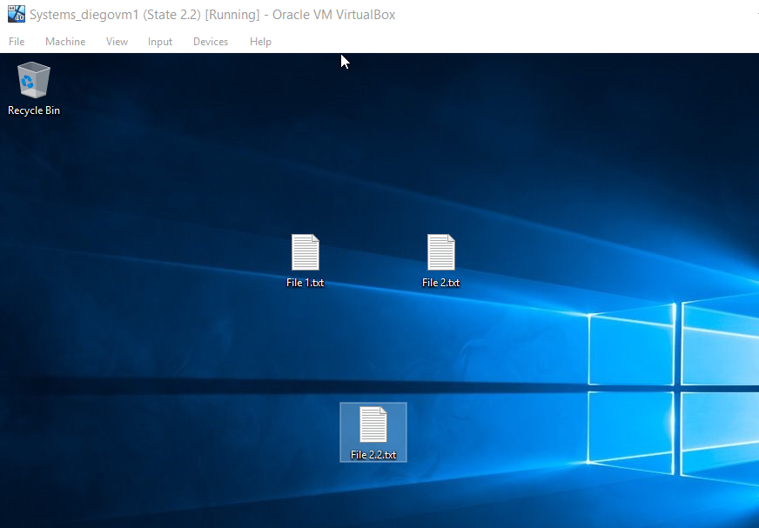

WE RESTORE STATE 2.2 AND WE CAN SEE THAT FILE 2.1 IS NO LONGER THERE BECAUSE THAT FILE BELONGED TO STATE 2.1.

• Delete State 2.2 and explain what happens

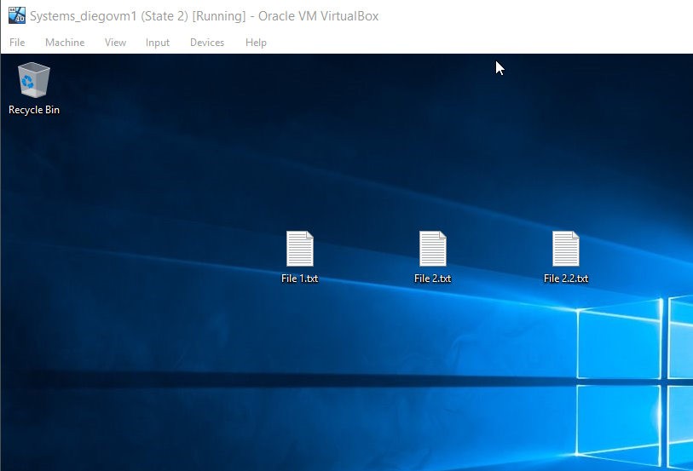

AS WE CAN SEE, WE ARE RUNNING STATE 2 AGAIN AFTER DELETING STATE 2.2 AS WELL AND WE NOTICE THAT EVEN THOUGH WE DELETED THAT STATE, WE STILL HAVE FILE 2.2.

